Beyond Symptom Relief: Listening to What the Body Is Saying
By Ajna Samadhi
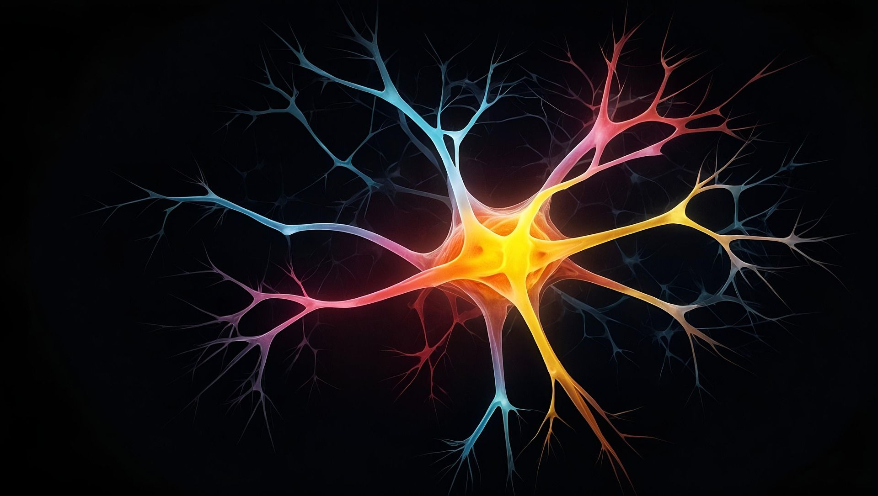
When Physical Pain Isn’t Only Physical
Before starting any treatment in my bodywork practice, I ask myself a series of questions:
What is in the way of this person being well?
What is preventing their next growth?
What is blocking them from expanding, from thriving?
Is their body aligned with what they are choosing to experience and be?

Previously, I focused primarily on musculoskeletal dysfunctions. By using various techniques to trace compensatory patterns back to their original injuries, these symptoms can be corrected with a combination of biomechanics, neuroscience, sensory receptor resets, and soft tissue manipulation. This is still a big part of my practice but it is more and more frequently the secondary integration work.
Over time I have observed that when we only treat the physical symptoms, they tend to return. Sometimes in the same place, sometimes somewhere new, sometimes in a completely different expression. When we aim only for symptom relief, we risk missing the opportunity to understand what could be contributing or causing those symptoms to begin with.
Physical pain and illness function like an internal alarm system. When we aim only to silence the alarm, we fail to look for the fire.
One of the drains on a person’s wellbeing I am observing, is a lack of authenticity – a distancing of honesty and integrity with oneself. Something else becomes more important. We are also vulnerable as social beings to be coerced to work against ourselves without even realizing it.
Case Study:
The clearest example of this at play happened recently. I was working with someone who came in unable to walk due to severe ankle pain. There had been no injury, fall, impact, or sprain— and the lack of mobility was beginning to affect their mental health. When I palpated their right ankle, it felt as though they weren’t fully inhabiting it. On a hunch, I asked about their mother.
They paused, then looked wide eyed. Their mother currently had a serious ankle injury on the exact same side.
We used muscle testing to explore further, and what surfaced was an old childhood dynamic: their system would not allow them to be better than their mother. When she was hurting, they had to hurt too. This pattern—formed early, and running unconsciously—was still shaping them and their reality. Once this pattern was recognized, they were able to consciously drop it and choose a new way of relating.
Only then did we address the physical work. With manual techniques and sensory receptor resets, we restored complete function to the ligaments and muscles of their foot and ankle… and they continue to be pain-free.
The physical work we did mattered, but if that is all we did, we would have missed a much larger dynamic at play—and the pain likely would have returned in some other form.
There is so much more to this work and to who we are that needs to be explored in a careful, grounded and systematic way. Symptoms are not just inconveniences to eliminate; they are signals. When we investigate them with curiosity rather than suppression, our body may offer a deeper clarity about ourselves and what our system may be trying to confess to.

