Rethinking Ice: Why Inflammation Is a Necessary Part of Healing

By Ajna Samadhi
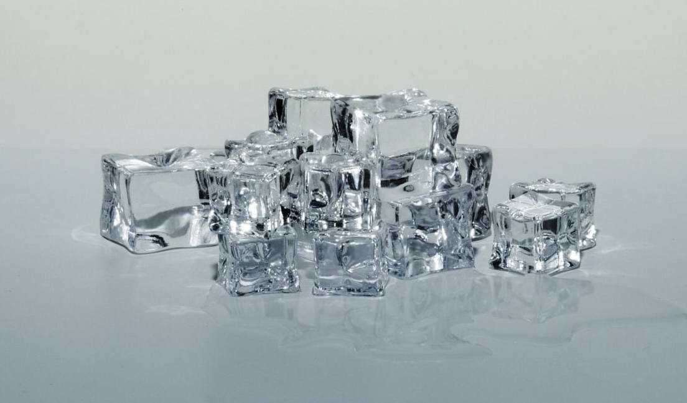

For decades, the standard response to soft-tissue injuries has been simple and familiar: RICE — Rest, Ice, Compression, Elevate. Introduced by Dr. Gabe Mirkin in 1978, the approach was designed to relieve pain and reduce inflammation, under the belief that limiting inflammation would speed up the healing process.

However, newer research has revealed a different theory. Inflammation for soft tissue injuries, as it turns out, is a crucial part of the body’s natural repair process. By interrupting it — whether through ice or anti-inflammatory drugs — we are actually impeding the cascade of biological signals responsible for tissue regeneration.

Ice can be helpful in the moment, acting as a temporary analgesic and reducing visible swelling. But studies show it does not significantly cool deeper muscle tissues. More importantly, it can blunt the inflammatory response that attracts the cells needed for healing. When used to help injured athletes return to the game, it has been shown to decrease an athlete’s strength, speed, endurance and coordination (Sports Med, Nov 28, 2011).

A new approach published in the British Journal of Sports Medicine (Aug 3, 2019) has been introduced as believe it or not: PEACE & LOVE — a protocol that promotes active recovery and long-term healing over short-term symptom suppression.
PEACE
• Protect
• Elevate
• Avoid anti-inflammatory drugs
• Compression
• Education

LOVE
• Load
• Optimism
• Vascularisation
• Exercise

This updated model emphasises gentle movement, healthy blood flow, and a supportive mindset, all shown to enhance recovery. Unless there is significant swelling or acute structural damage, ice is often unnecessary and may even hinder progress.

Interestingly, even Dr. Mirkin has since retracted his original recommendation, acknowledging that inflammation plays an essential role in acute soft tissue injuries.
It will be interesting to witness how long the general public will take to adopt this new protocol, given our tendency to default to old habits that offer a sense of knowing despite new evidence.

Want to Read More?
• Dr. Mirkin’s retraction and research summary: https://drmirkin.com/fitness/why-ice-delays-recovery.html
• PEACE & LOVE paper in the British Journal of Sports Medicine: https://bjsm.bmj.com/content/bjsports/54/2/72.full.pdf

Bonus Tip:
Consider skipping the ice bath after your next workout. The mild inflammation produced during exercise is what stimulates muscle growth and adaptation. Cooling the body too quickly can interfere with this natural process, reducing both recovery and strength gains.

